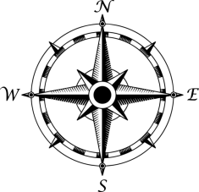

NG7

IR13

**Campers**

SH9

SH10

BS1

BS4

BS3

BS2

**Bandshell**

FC2

FC1

**Food Stand**

**Food Stand**

A2

A1

SH11

SH4

SH3

SH2

SH1

SH5

SH6

SH7

SH8

**Wood Carver**

**Parking Lot**

**Sterl Hall**

NG1

NG2

NG3

NG4

NG5

NG6

VR6

VR5

VR3

VR2

VR1

VR4

**Food Stand**

**Food Stand**

IR16

IR15

IR14

IR12

IR11

IR10

IR9

IR1

IR2

IR3

IR4

IR5

IR6

IR7

IR8

**Food Stand**

**Food Stand**

XXX