R3
R4
R5
R6
Dodge Rodeo Space
R1
R2
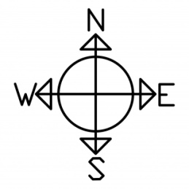
Show Barn

Stadium
Beef Barn
G8
G7
G6
Band Shell
Food stand
Food stand
Food stand
Food stand

