Purchasing Advance Tickets/Armband Online

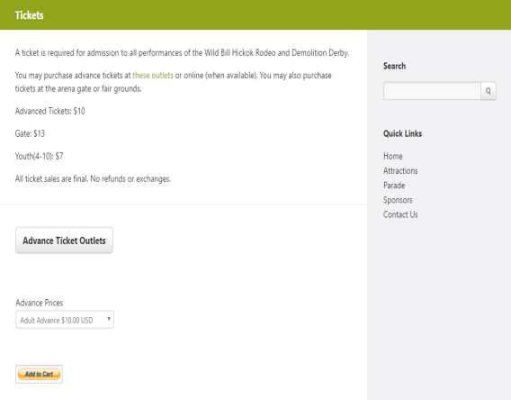

Select the ticket or wristband you would like to purchase from the drop down menu

Then click Add to Cart

If purchasing multiple, select your first option (has to be added to cart individually)

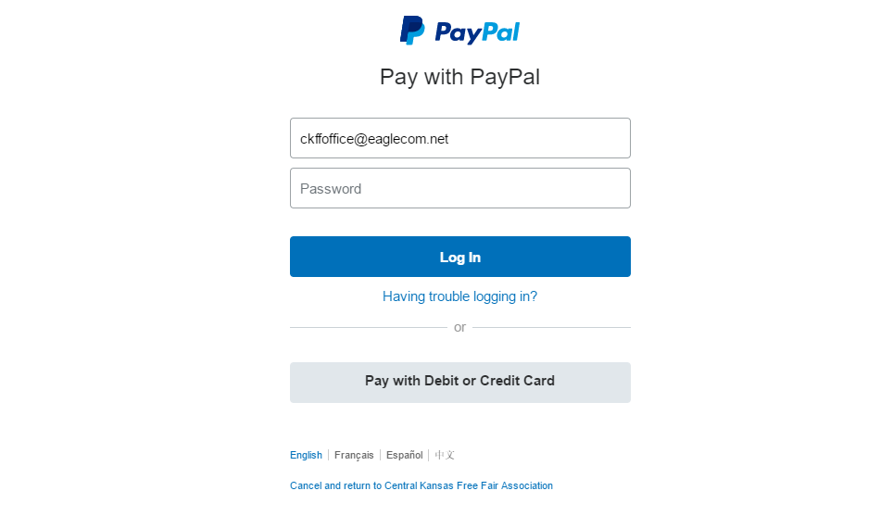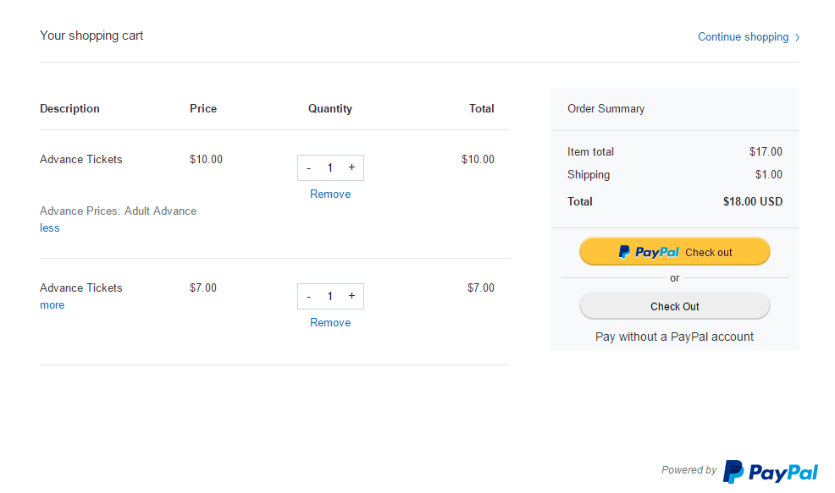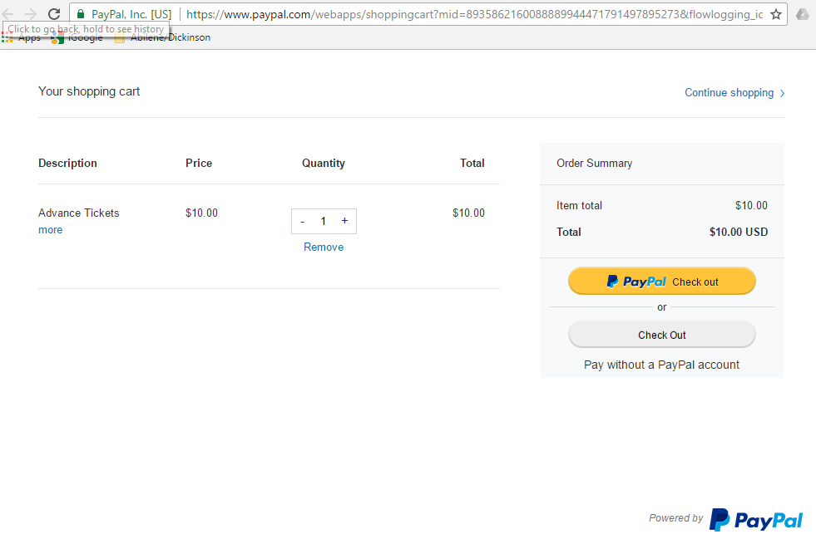

**A $1.00 Shipping fee is added for handling purposes**

**Tickets will be mailed out unless too close to fair**

**Tickets should then be picked up at the information booth in front of Sterl Hall**

**Online ticket sales will stop July 28**

**Tickets can then be purchased at area outlets**

**3**

**4**

**2**

**1**

Select Pay with Debit or Credit Card and proceed to fill out the card and billing info

Click continue when finished

If you have more to buy, select continue shopping

You should then be taken back to the CKFF Tickets page

Select your next option from the drop down menu and click “Add to Cart”

You will be taken back to the PayPal page and your cart should have your ticket/armband purchases listed

Continue this process for the rest of your purchases

When finished, select Check Out

After clicking “Add to Cart” you will be taken to a new page.