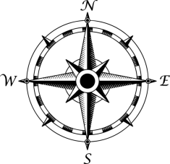

**Equine Exercise Arena**

BD17 20’

BD16 20’

BD15 20’

BD14 20’

BD13 20’

BD12 20’

‘

BD11 20’

BD10 20’

‘

BD9 20’

BD8 25’

BD7 30’

‘

BD6 30’

BD5 30’

‘

**Ball Diamonds**

BD1 40’

BD2 40’

BD3 40’

BD4 30’

BD18 20’

BD19 20’

BD20 20’

BD21 20’

BD22 20’

BD25 20’

BD23 20’

BD24 20’

BD26 30’

BD27 30’

**Horse Barn**